**Practical DevOps– Assignment on AWS**

1. **Setting up a CI/CD Pipeline and deploying applications on AWS EKS**

**Step 1: Create a terraform file to provision and manage resources on AWS**

* Refer link : <https://github.com/Chau-NH/sd4322_aws_infrastructure>

**VPC**

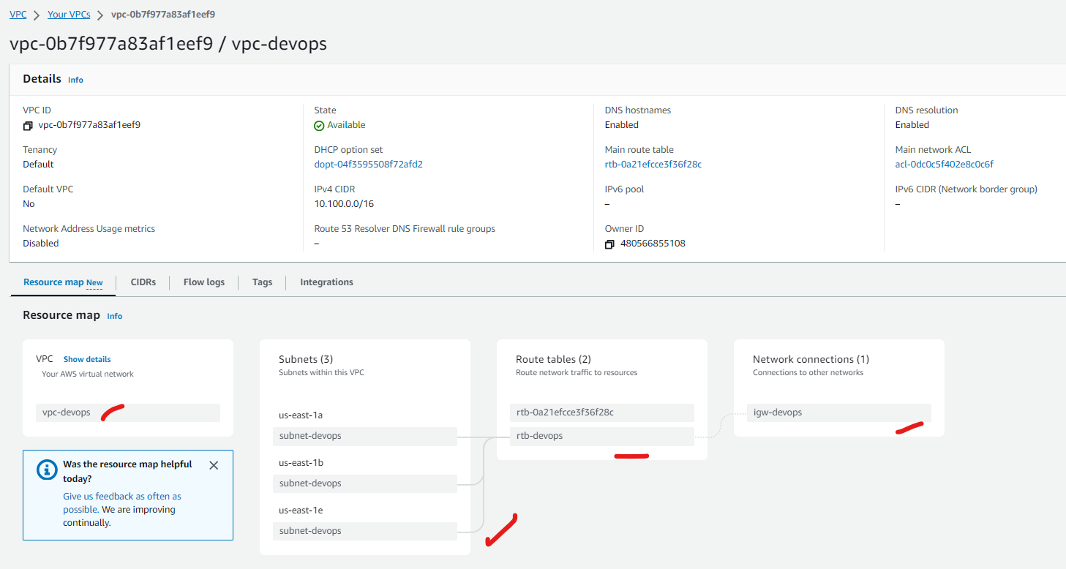

**EKS**

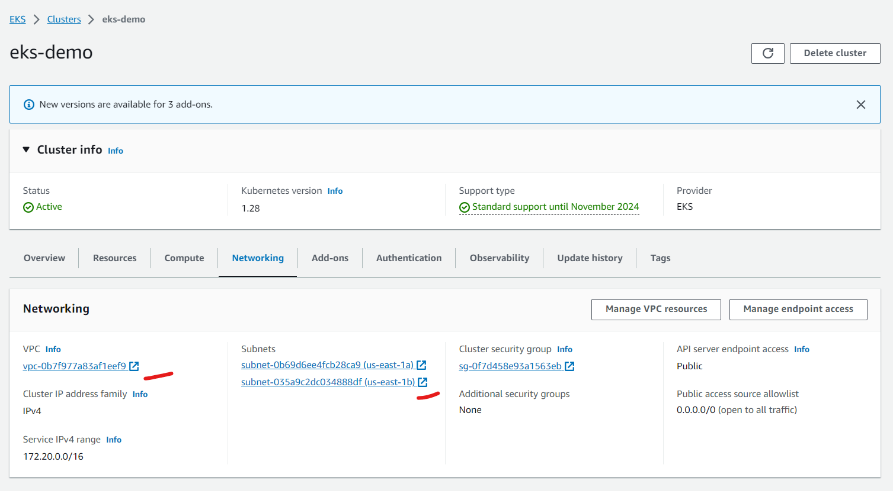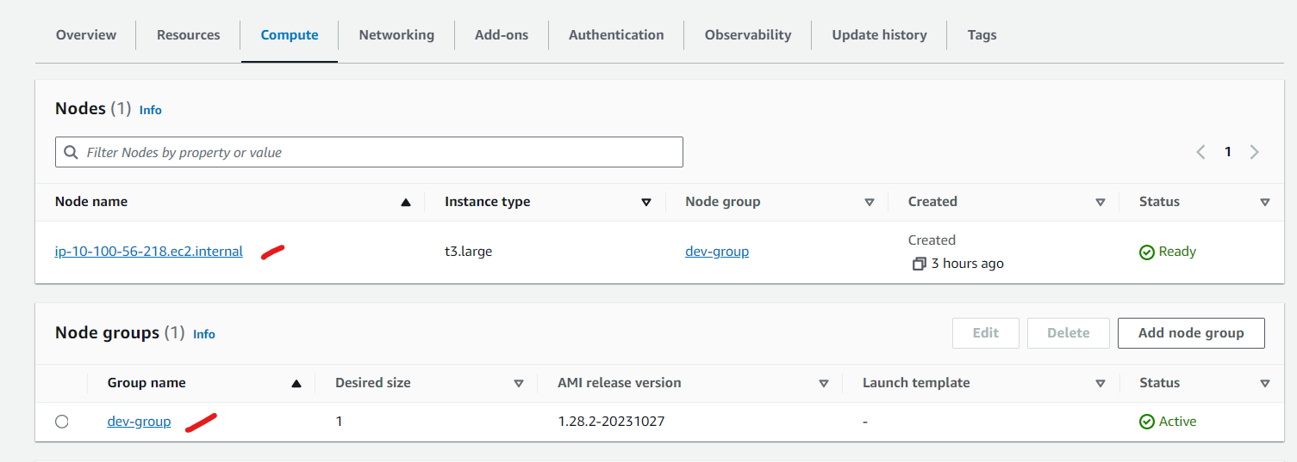

**ECR**

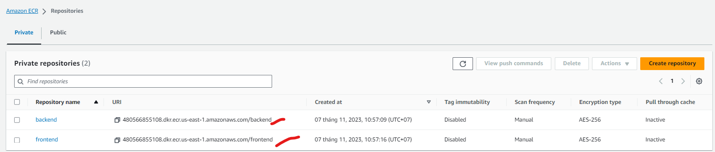

**Step 2: Set up Jenkins for CI process applying Shared Library and Trivy**

* Source code for micro services: **frontend and backend**
  + <https://github.com/Chau-NH/frontend>
  + <https://github.com/Chau-NH/backend>
* Source code for Jenkins Pipeline**: jenkins-devops** (apply Shared Library)
  + <https://github.com/Chau-NH/jenkins-devops>

**GitHub repositories:** 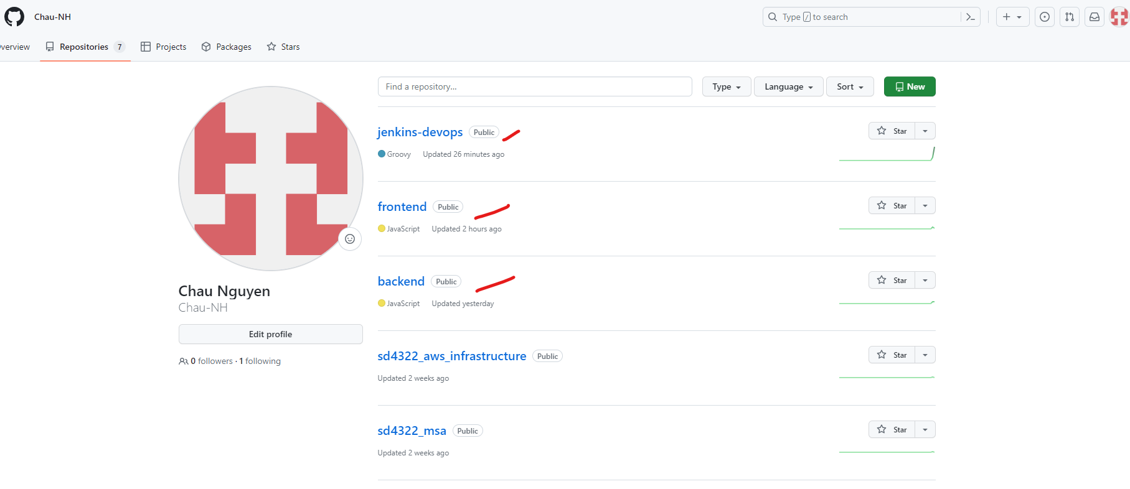

**Backend Pipeline**

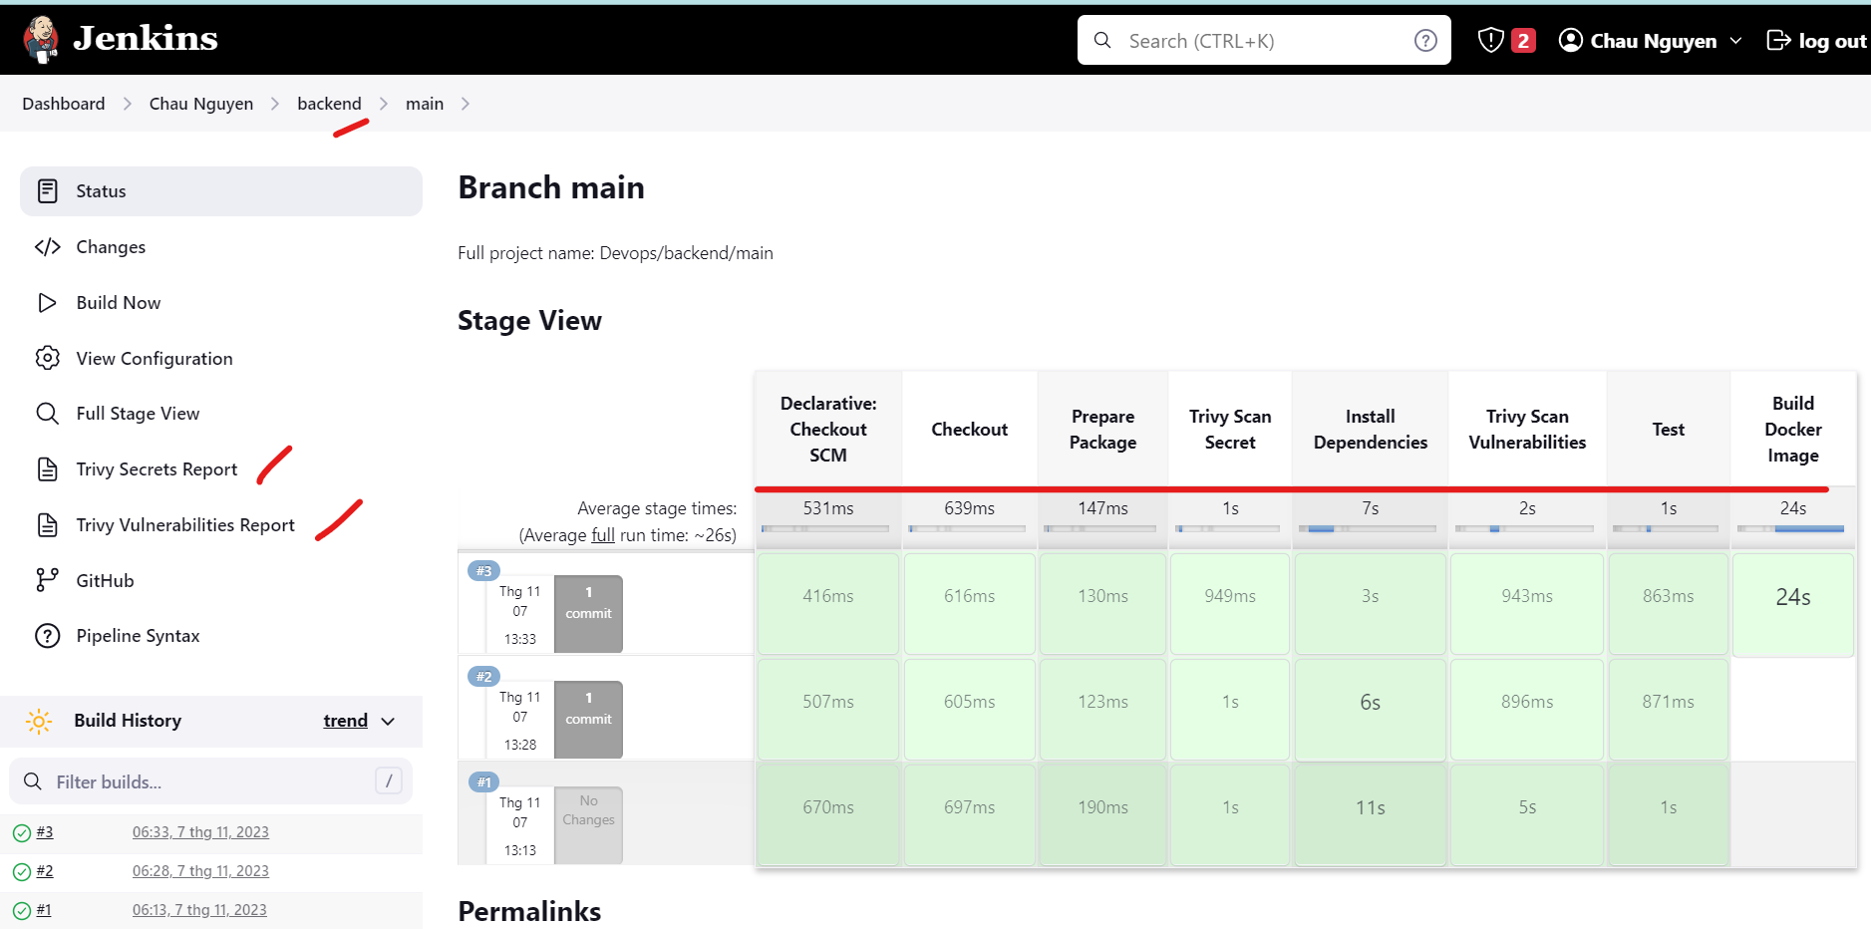

**Frontend Pipeline**

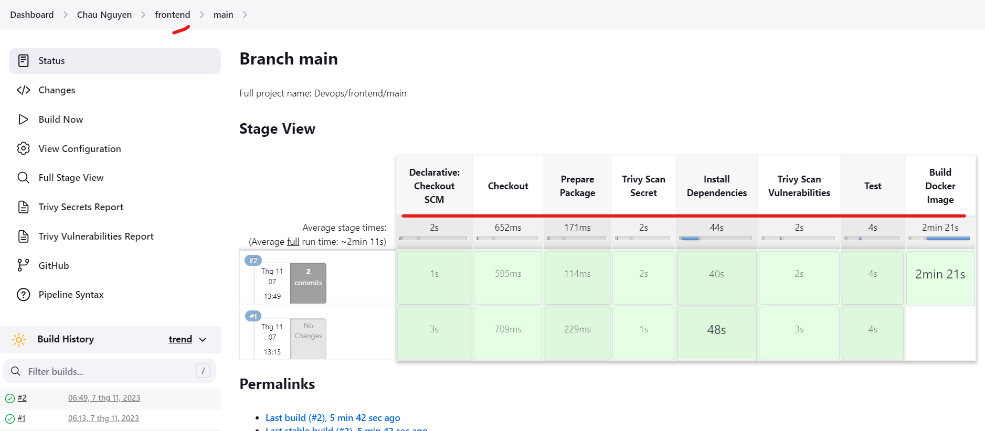

**Trivy security scan result**

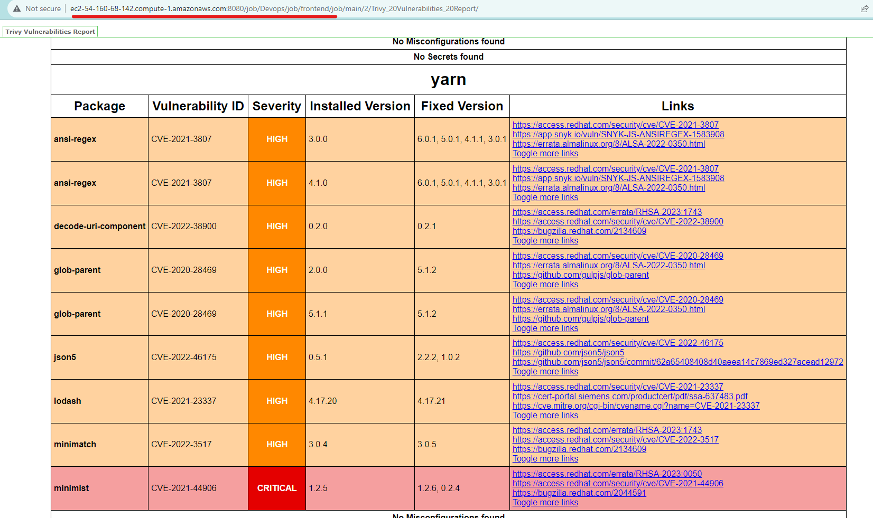

1. **Set up ArgoCD for CD process working with Helm charts**

**Step 1: Create a Helm chart repository to manage manifest**

* Source code for Helm chart: <https://github.com/Chau-NH/helm-charts>
* In order to apply **Promotion Environment pattern** we will create values.yaml file for each environment
  + Dev: values-dev.yaml
  + Staging: values-staging.yaml
  + Production: values-prod.yaml

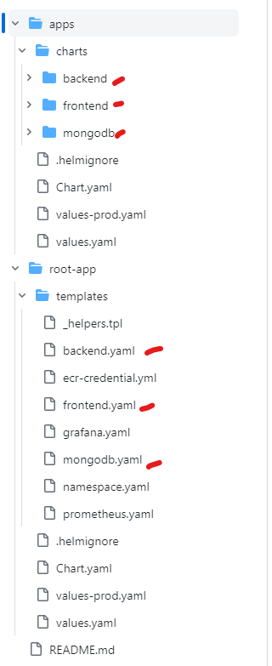

**Step 2: Install ArgoCD and create application with ArgoCD**

**Result on terminal**

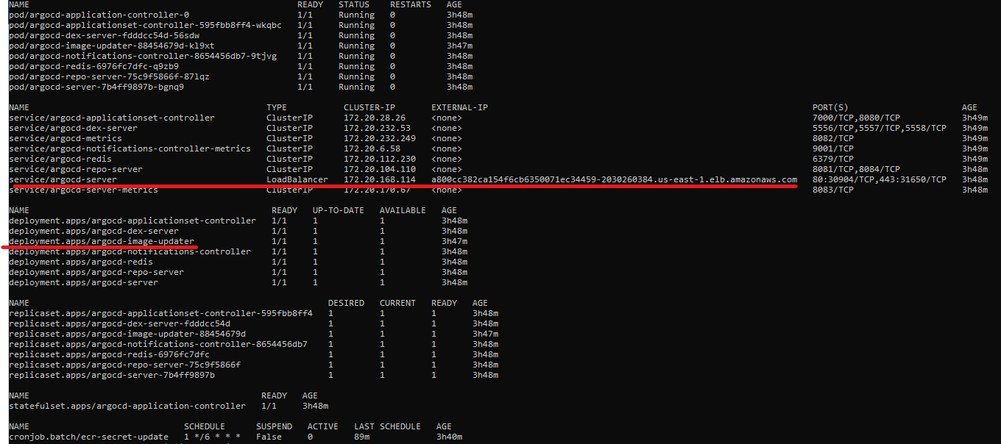

**Result on UI**

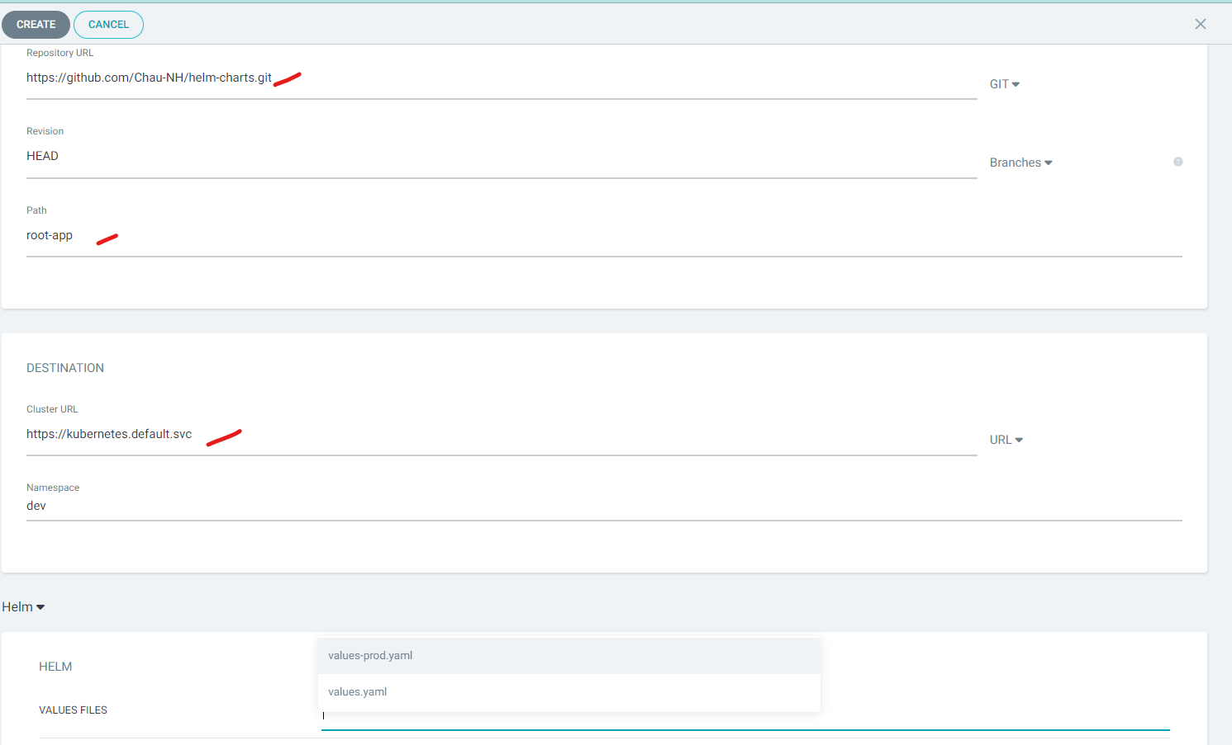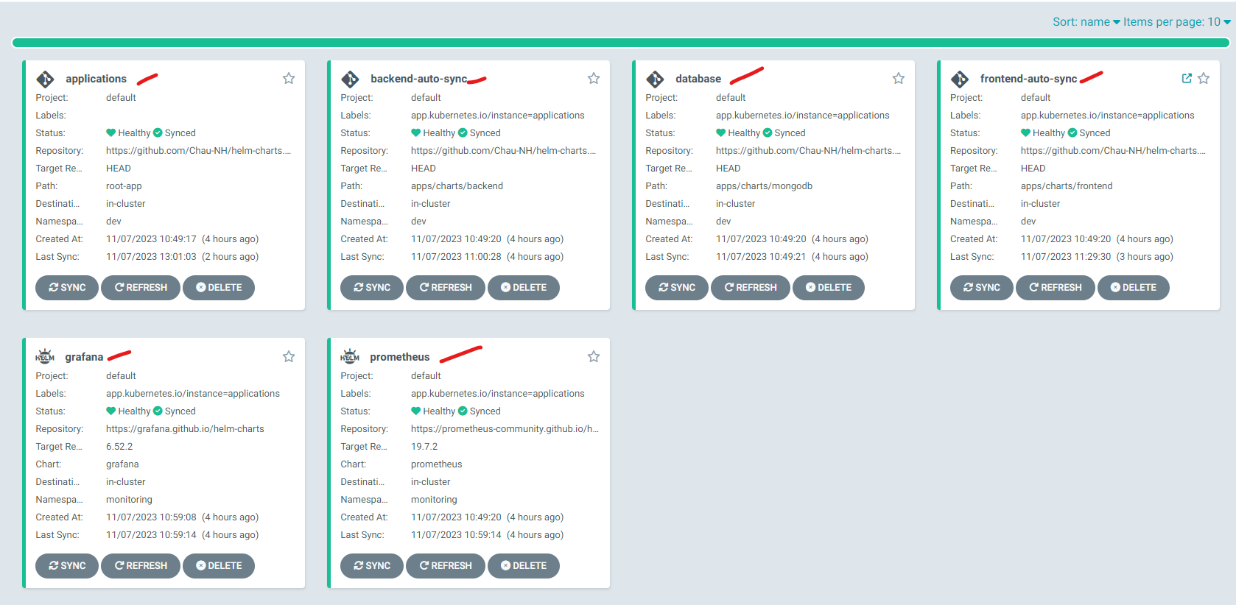

**Backend  
  
Frontend**

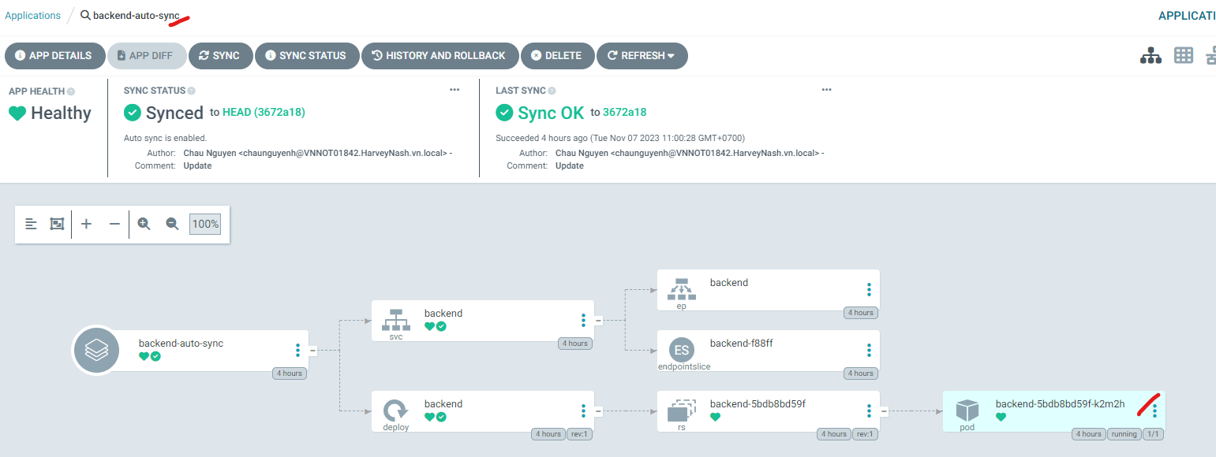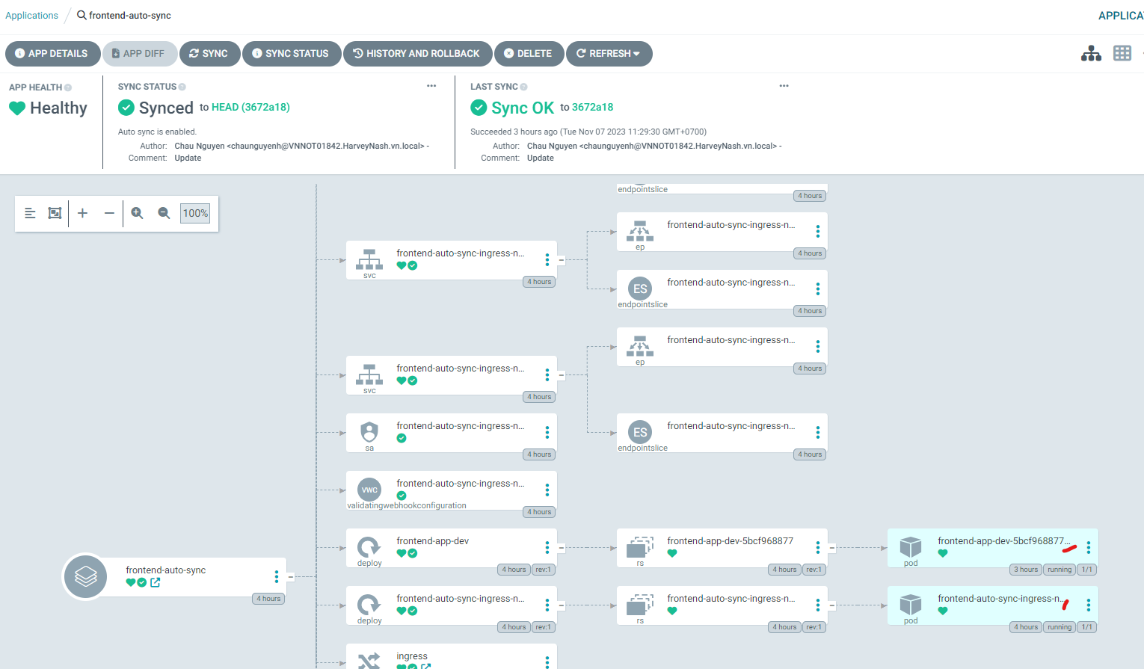

**Step 3: Using ArgoCD Image Updater to deploy automatically**

* Apply ArgoCD Image Updater to Backend and Frontend
* We apply **Digest strategy** for ArgoCD Image Updater.

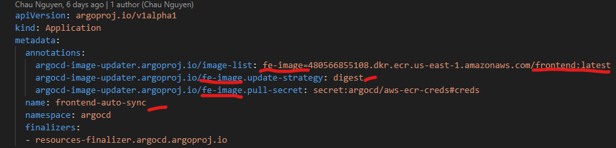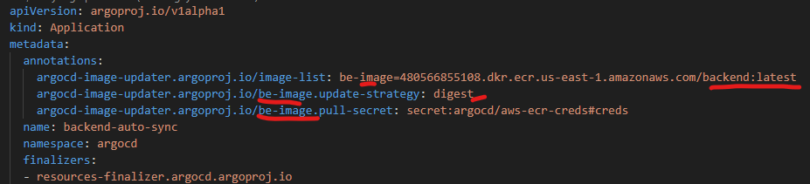

* **Digest strategy** updates to the latest version of a given version (tag), using the tag's SHA digest

**Step 4: Check whether ArgoCD Image Updater is woring or not**

**Go to UI before pushing code**

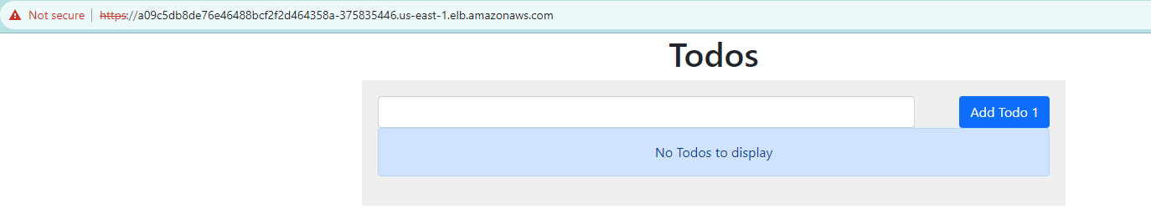

**Push a commit to repo**

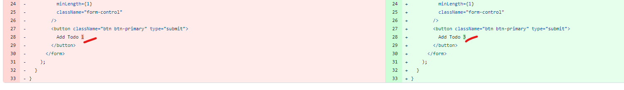

**Jenkins automatically run for every push (Webhook added)**

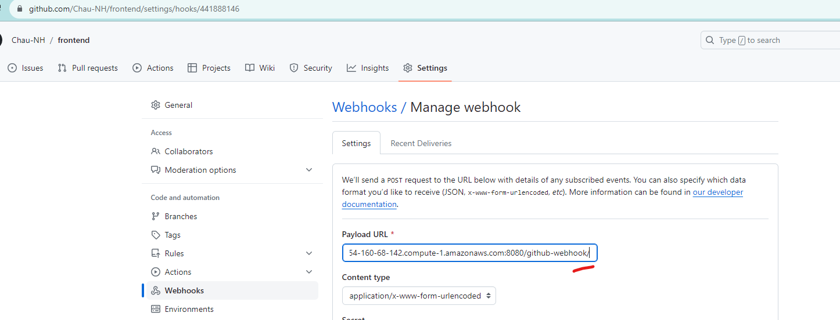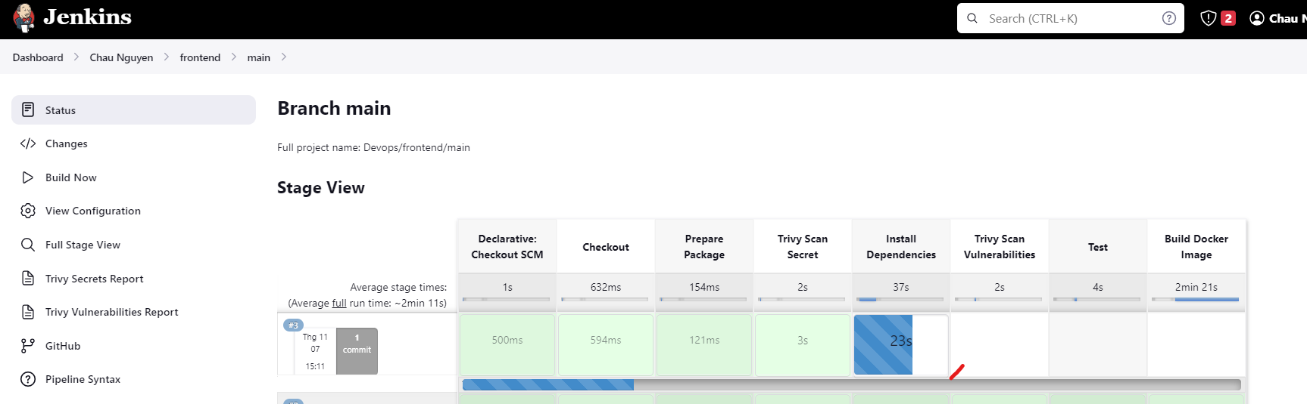

**ArgoCD automatically run after new Docker image uploaded**

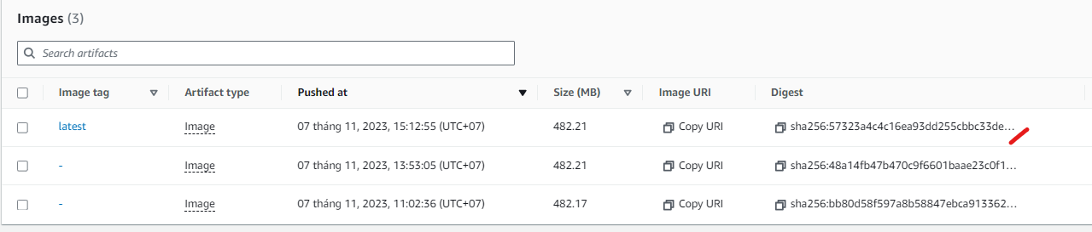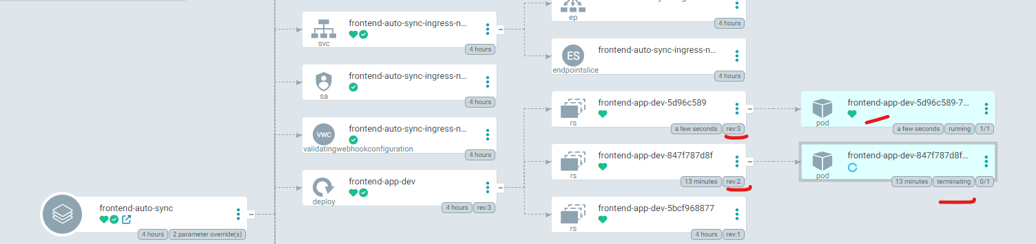

**Go back to UI**

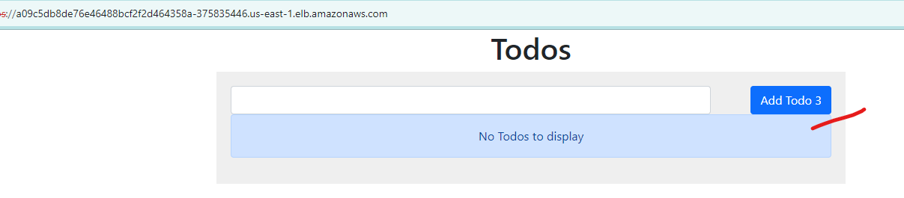

**Check logs of Argocd Image Updater**

Run : kubectl logs deployment.apps/argocd-image-updater -n argocd



1. **Set up Prometheus and Grafana with Helm charts**

**Argocd UI**

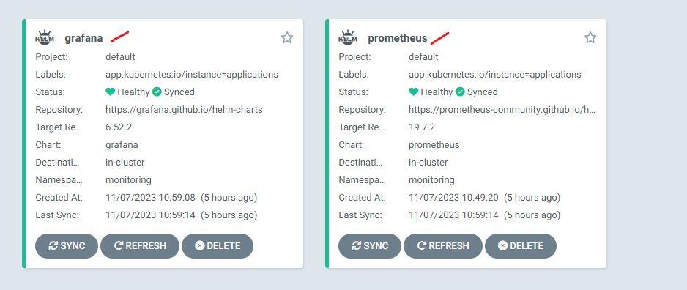

**Ternimal**

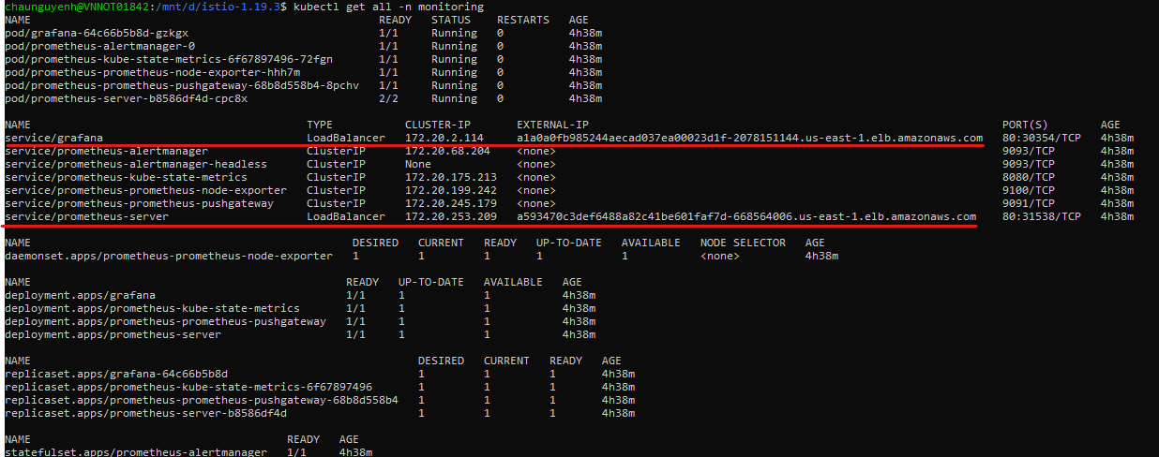

**Prometheus UI**

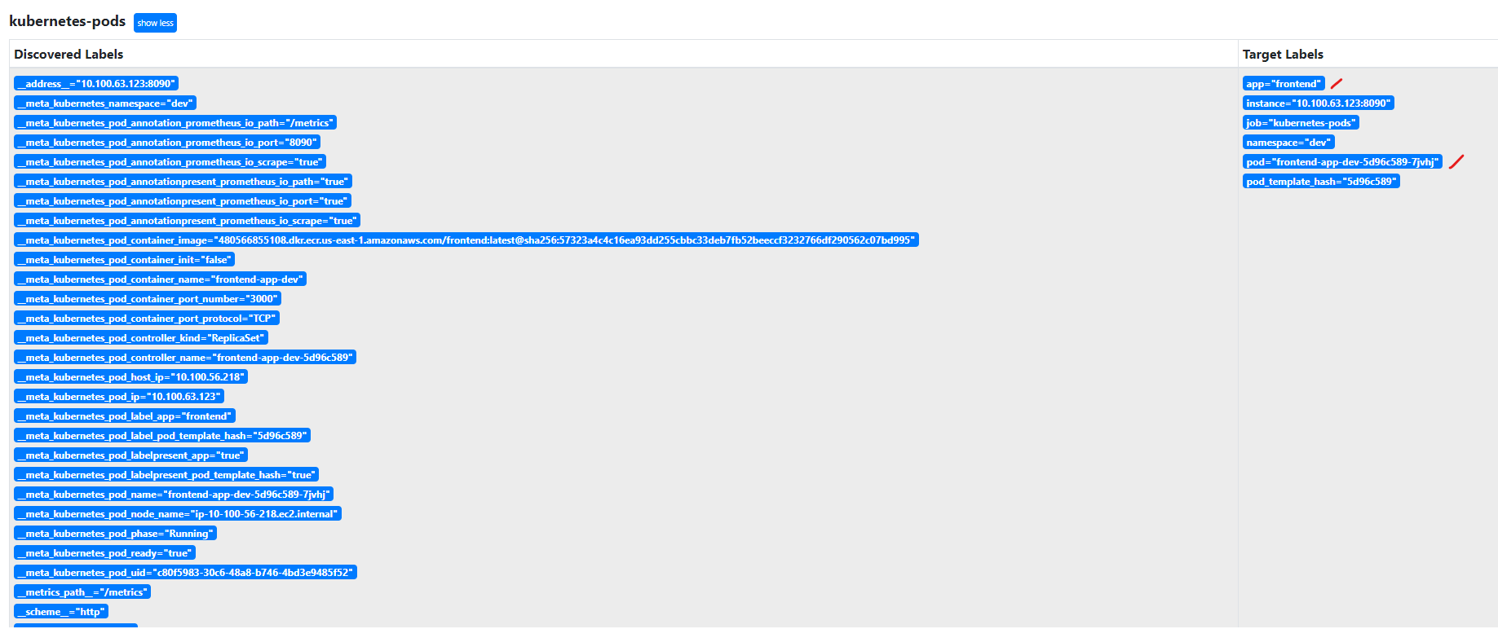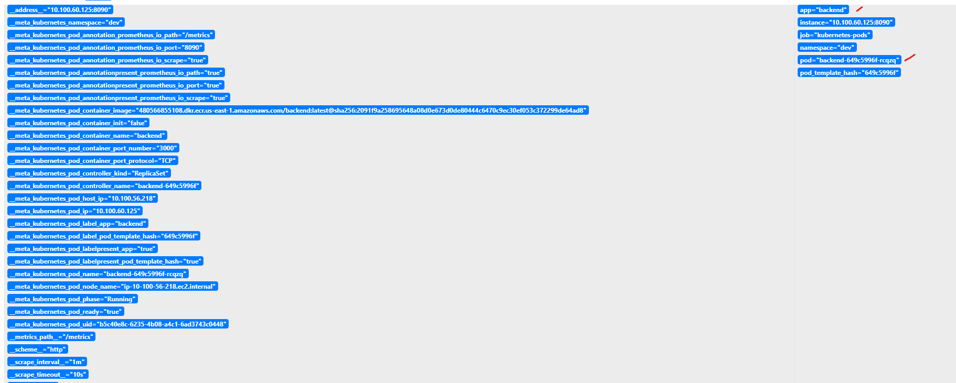

**Grafana UI**

